Retrirement Run Across Scotland
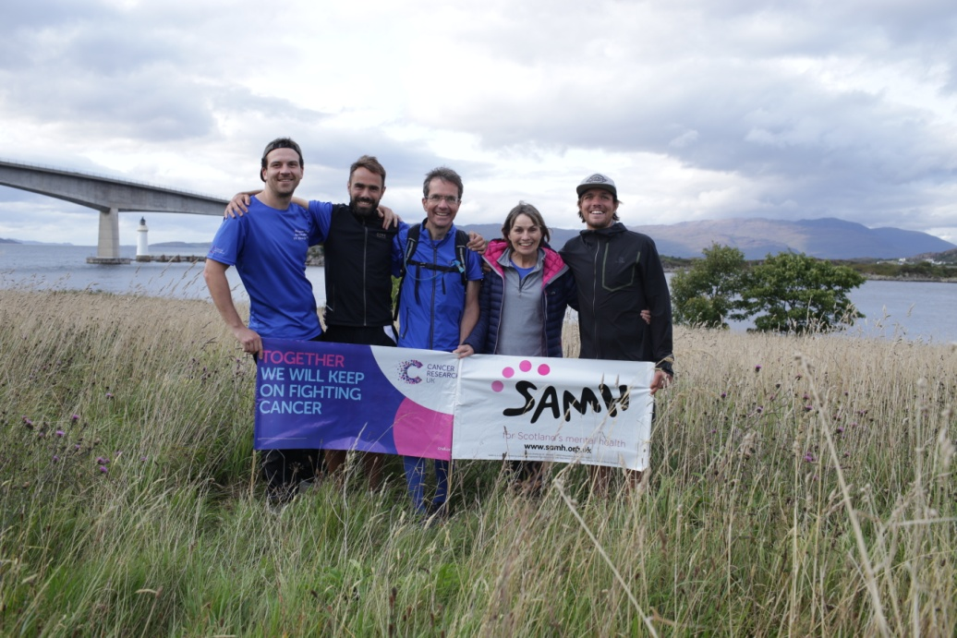
Dear All,
We finished our 4 day Run Across Scotland on Wednesday August 22nd, crossing over the Skye Bridge, having set off from the Kessock Bridge in Inverness on the Sunday.
87 miles (due to a minor navigation error!) and a total running time of just over 13 hours.
It was an incredible experience and a whole lot of fun. Weather was thankfully kind and yes, we did manage to run just fast enough to keep ahead of the midges!
So far we have raised, along with Gift Aid, just over £9,000 for our 2 charities, which we are all thrilled about.
Thanks again to you for your sponsorship, and comments of support along the way. Very much appreciated.
And a big thanks too, for our support crew of Rhona, and Richard Watson of Flux Video who was filming our adventure.
THANKS FOR YOUR SUPPORT EVERYONE !!
Alan, Gregor and Cameron
P.s. our fundraising page is still open at: www.mydonate.bt.com/fundraisers/matthewsrunacrossscotland

